File carving analysis of Pagefile.sys

SeungJu Cha¹ EunJung Choi²

¹Dept. of Information Security, Seoul Women’s Univercity
Seoul Women’s Univ., Gongneung 2(i)-dong, Nowon-gu, Seoul 139-774, KOREA
Seoul, Republic of Korea
cktmdwn01@gmail.com
²prof. Dept. of Information Security, Seoul Women’s Univercity
Seoul Women’s Univ., Gongneung 2(i)-dong, Nowon-gu, Seoul 139-774, KOREA
Seoul, Republic of Korea
chej@swu.ac.kr

Abstract

Recently, various issues related to forensics can be found. As these forensic issues become more numerous, the anti-forensic approach to preventing them is also increasing.After over time or exploiting the characteristics of RAM, It is difficult to analyze the data in the memory. However, if the data you want to analyze exists in virtual memory through paging, you have the possibility to analyze it. These page files use pagefile.sys in the Windows operating system, and the data swapped out in RAM remains page-by-page in pagefile.sys. Therefore, in this paper, I recover the file by imaging the pagefile.sys file data with file format.

keywords: pagefile.sys, virtual memory, file carving, memory and imaging

I. Introduction

Recently, various issues related to forensics can be found. As these forensic issues become more numerous, the anti-forensic approach to preventing them is also increasing.After over time or exploiting the characteristics of RAM, It is difficult to analyze the data in the memory. In general, a memory forensic random access memory (Ram) is a main storage device capable of reading and writing to an arbitrary area. Collecting “live” memory is not an easy task[1]. Generally, RAM, which is commonly used, is a DRAM of volatile type, and data is volatilized unless it is periodically recharged to maintain recorded contents. Therefore, after over time or exploiting the characteristics of RAM, It is difficult to analyze the data in the memory. However, if the data you want to analyze exists in virtual memory through paging, there is a possibility of analyzing this data. These page files use pagefile.sys in the Windows operating system, and the data swapped out in RAM remains page-by-page in pagefile.sys. So if I can not find anything in RAM, I can find it as a treasure hunt from pagefile.sys.

II. pagefile.sys Analysis

- pagefile.sys

The operating system uses a page file to store information that should be in physical memory[3].The Windows operating system provides virtual memory, which is limited in the amount of RAM that can be used to provide virtual memory for persistent storage such as a hard disk.
To provide more virtual memory as is physically present inform of RAM modules, an operating system may swap parts of the virtual memory out to persistent storage[1].Hence, datain the virtual address space may not always be present in the physical main memory of a computer system, but only in the persistent storage of that system. The location of the virtual memory on the persistent storage is known as the pagefile[1].

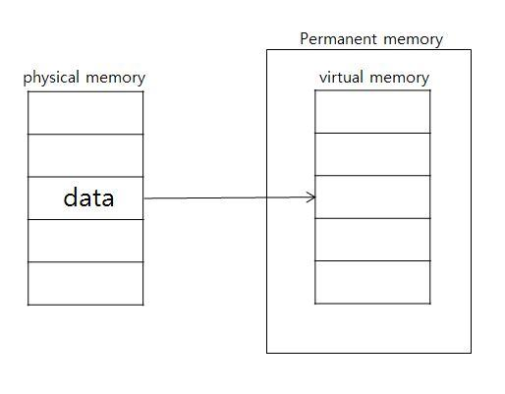

Fig. 1 Paging from Physical memory and virtual memory(pagefile.sys)

When you want to process the processor's data for immediate use in RAM, swap the low-priority or sleep state data in the RAM to virtual data. These page files use pagefile.sys in the Windows operating system, and the data(Various data such as html or javascript used in browser, Facebook’s instant messaging service[4], WIN api or data value used in exe etc.) swapped out in RAM remains page-by-page in pagefile.sys. Therefore, in this paper, I try to recover the file by imaging the pagefile.sys file.

- File carving from pagefile.syss

First, in the Windows operating system environment, the pagefile.sys file can be found in the root directory of the C drive. You can find various data in the extracted pagefile.sys. You can find it by searching the file format of the desired file such as jpeg, pdf, exe etc.

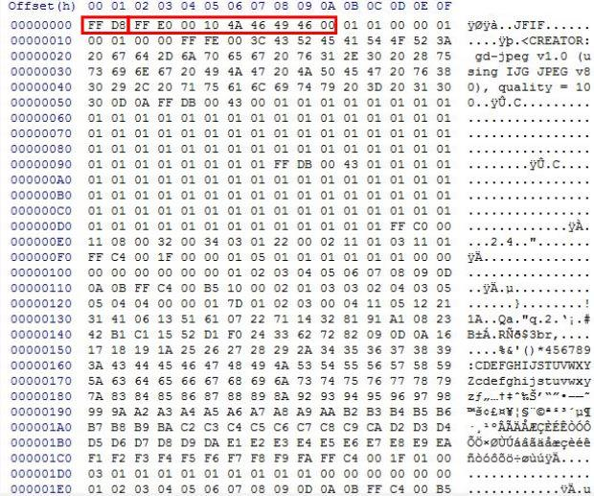

Fig. 2 Paging from Physical memory and virtual memory(pagefile.sys)

For example, to recover a jpeg file, we look for data in that format. After confirming the actual jpeg file format from the data, editing it for formatting, and changing the extension, file carving can be succeeded. But it can not expect to recover a complete file. The reason is that when the data of the executed process is stored in the virtual memory, it is stored in a page unit, and data of one page can be retrieved and recovered.

V. Conclusion
We can find the data as follows, edit the data according to the file format, and then carve the file to get the desired data. However, because of the characteristics stored in pages, it not be possible to cabbing or carbability if the entire data is not stored. Although there is a limit, I think that if it can't imaging data about RAM, you might find it possible to find the desired data through pagefile.sys. After, I will try to recover the more accurate file discovering by the rules for the data in the same process.

Acknowledgment

This research was supported by the MIST(Ministry of Science and ICT), Korea, under the National Program for Excellence in SW supervised by the IITP(Institute for Information & communications Technology Promotion)(2016-0-00022)

References

- Nicolas Ruff, “Windows memory forensics” Springer-Verlag France, November 2007.
- Michael Gruhn, “Windows NT pagefile.sys Virtual Memory Analysis” Erlangen, Germany, May 2015.
- Matthew Kiley, Shira Dankner and Marcus Rogers, “FORENSIC ANALYSIS OF VOLATILE INSTANT MESSAGING” Conference proceedings DigitalForensics 2008
- Noora Al Mutawa, Ibtesam Al Awadhi, Ibrahim Baggili, and Andrew Marrington, “Forensic artifacts of Facebook's instant messaging service” United Arab EmiratesJanuary 2011

